**Date:**

**Roll :**

**EXPERIMENT 6**

**Aim:-**  **Installation of NS2 / NS3 on Ubuntu**

**Theory**:

NS2 (Network Simulator 2) and NS3 (Network Simulator 3) are popular network simulators used for research and education in the field of networking. NS2, developed in the mid-1990s, is an older tool that allows users to simulate various network protocols, such as TCP, UDP, and routing algorithms like AODV and DSR. It uses a combination of C++ for core development and OTcl for scripting. However, NS2 is now considered outdated due to its complexity and limited scalability for larger simulations.

* **NS2:**
* **Release:** Older simulator, developed in the mid-1990s.
* **Language:** Primarily uses C++ for core functionality and OTcl (Object Tool Command Language) for scripting.
* **Focus:** Focuses on wired and wireless networks, supporting many network protocols (e.g., TCP, UDP, FTP, and routing protocols like AODV and DSR).
* **Limitations:** NS2 is considered outdated due to its complex codebase and limited scalability for large simulations.
* **NS3:**
* **Release:** Successor to NS2, designed to overcome the limitations of NS2.
* **Language:** Written entirely in C++, with optional Python scripting support.
* **Focus:** NS3 focuses on a wide range of modern network types, including Wi-Fi, LTE, 5G, and Internet of Things (IoT).
* **Advantages:** Offers better performance, scalability, and more realistic simulation of modern networking protocols. It also has better modularity and flexibility for researchers.
* **Steps to Install NS3 on Ubuntu (for Linux systems):**

1. **cat /etc/lsb-release :**

The command cat /etc/lsb-release is used to display the contents of the file /etc/lsb-release. This file contains information about the Linux distribution you are using, based on the Linux Standard Base (LSB) specification.

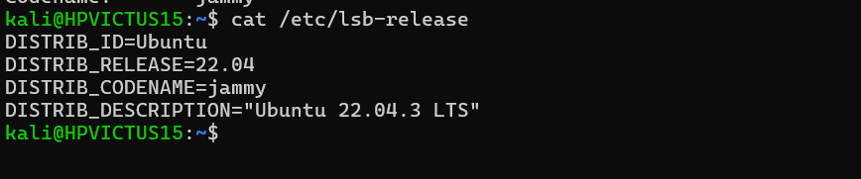

1. **sudo apt update :**

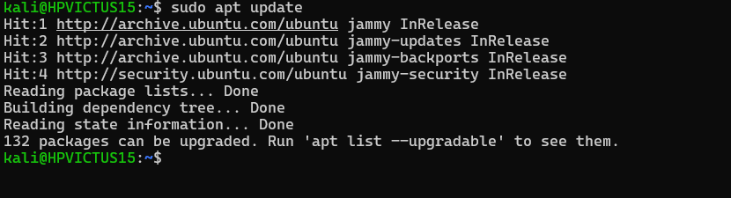

1. **sudo apt install build-essential autoconf automake libxmu-dev**

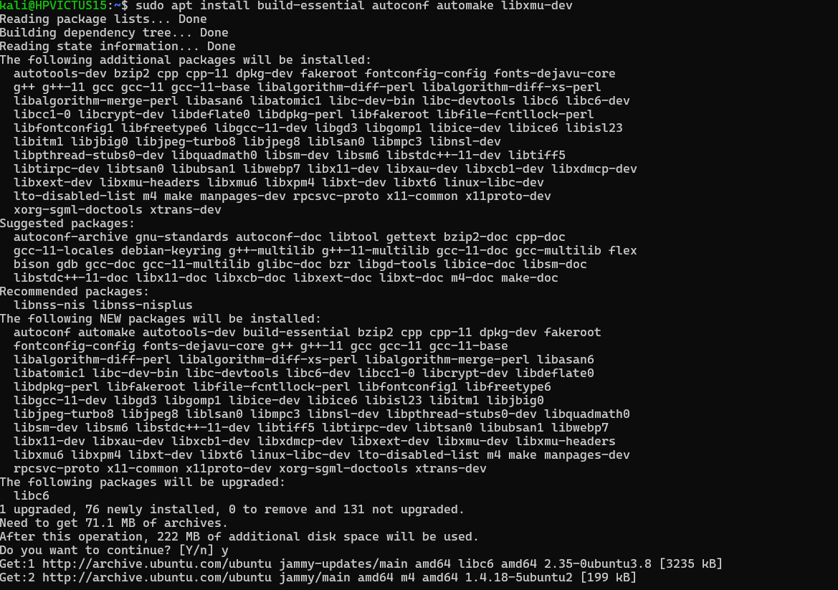

1. **installing resources for NS2**
2. **gcc and g++**
3. **sudo nano /etc/apt/sources.list**

and add this line in last

deb http://in.archive.ubuntu.com/ubuntu/ bionic main universe

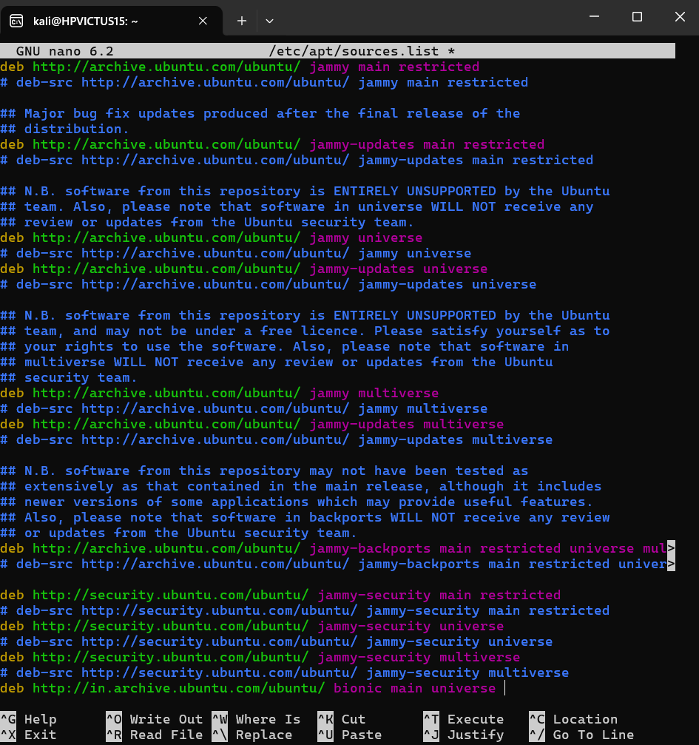

1. sudo apt update :

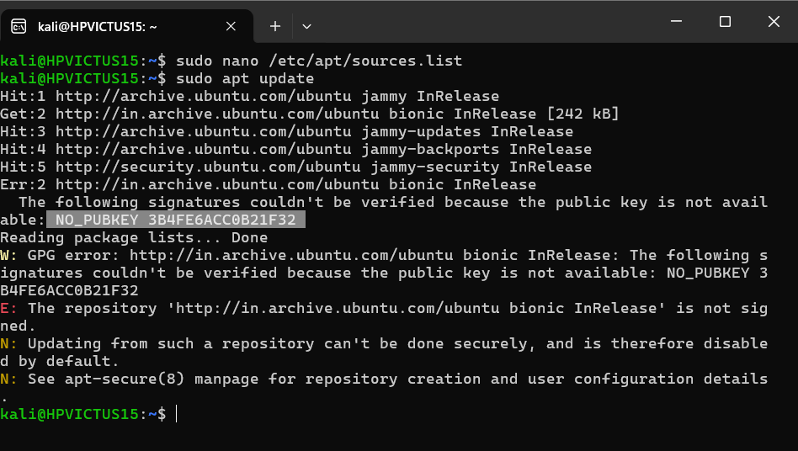

This giving an error of for any GPG error executed command given below

1. sudo apt-key adv --keyserver keyserver.ubuntu.com --recv-keys 3B4FE6ACC0B21F32

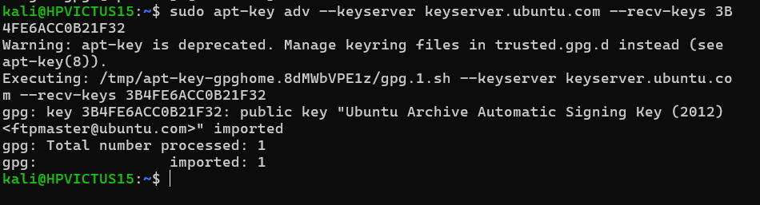

1. now again sudo apt update

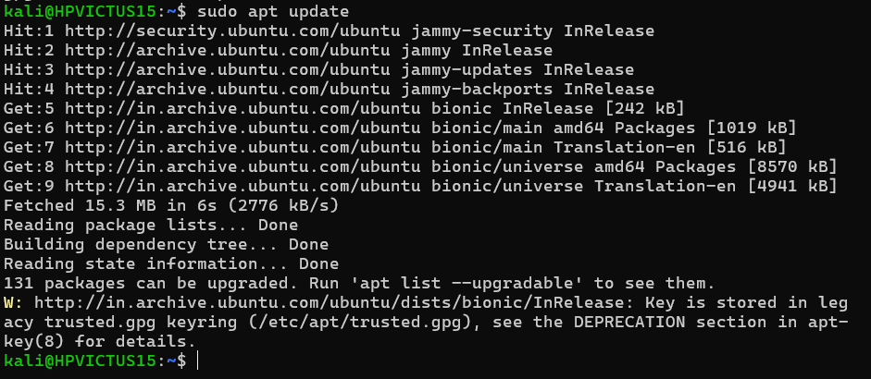

1. sudo apt install gcc-4.8 g++-4.8

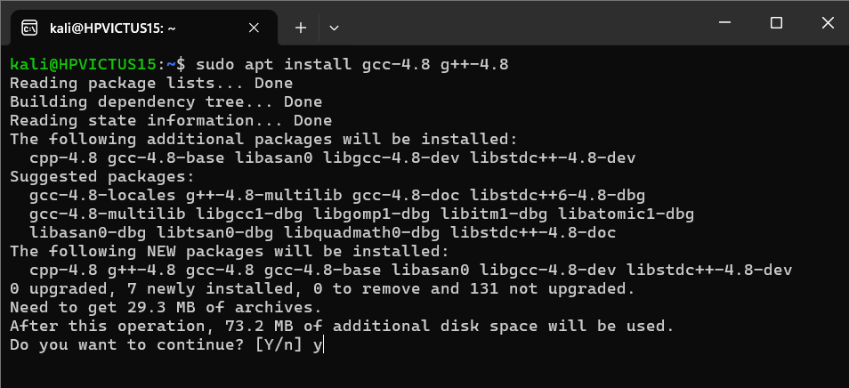

1. cd /mnt/c/Users/advai/Downloads/ns

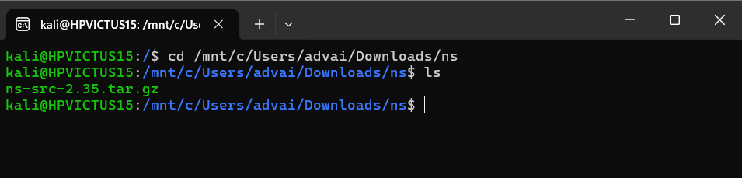

1. download NS2 from ‘ https://sourceforge.net/projects/nsnam/ ’
2. tar -xzvf ns-src-2.35.tar.gz (unzip file )

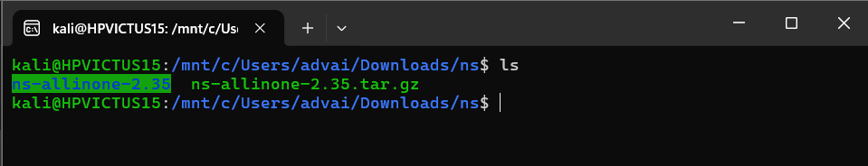

1. cd ns-allinone-2.35/ns-2.35



1. nano makefile.in :

make the changes in following files

@CC@ to be replaced with gcc-4.8

@CPP@ to be replaced with g++-4.8

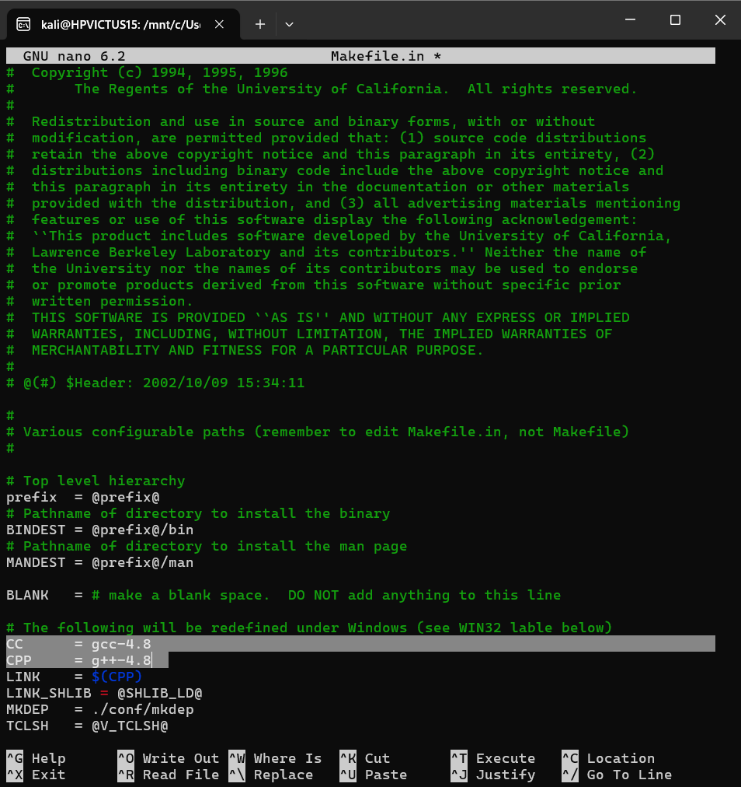

1. **cd otcl-1.14/**
2. **Nano MAkefile.in :**

make the changes in following files

@CC@ to be replaced with gcc-4.8

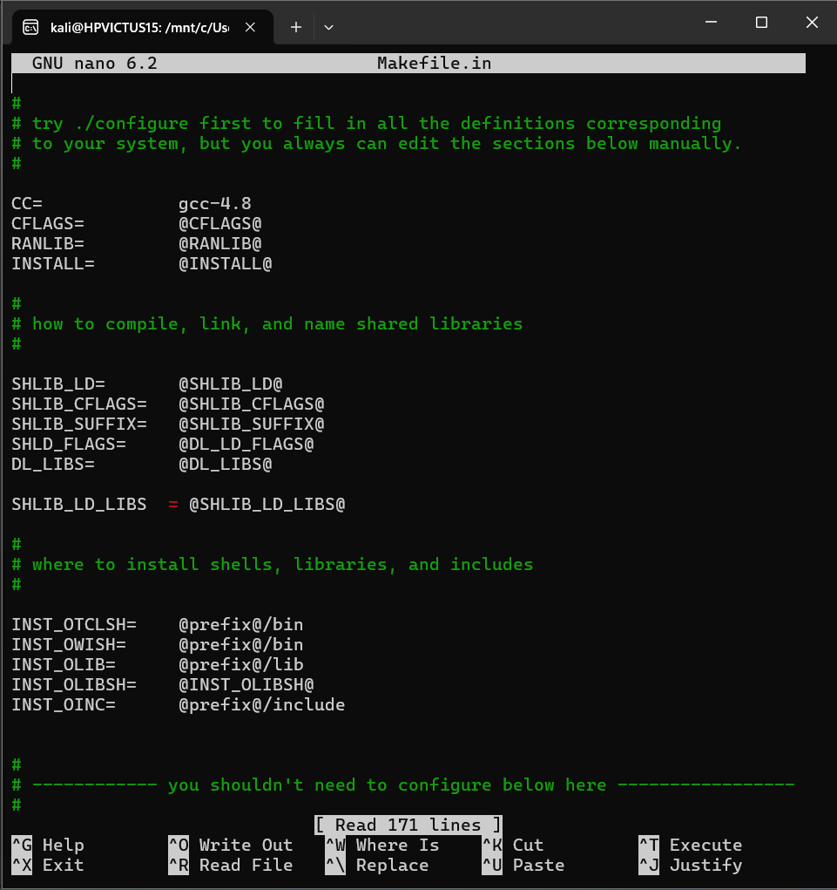

1. cd /mnt/c/Users/advai/Downloads/ns/ns-allinone-2.35/nam-1.15

nano Makefile.in

make the changes in following files

@CC@ to be replaced with gcc-4.8

@CPP@ to be replaced with g++-4.8

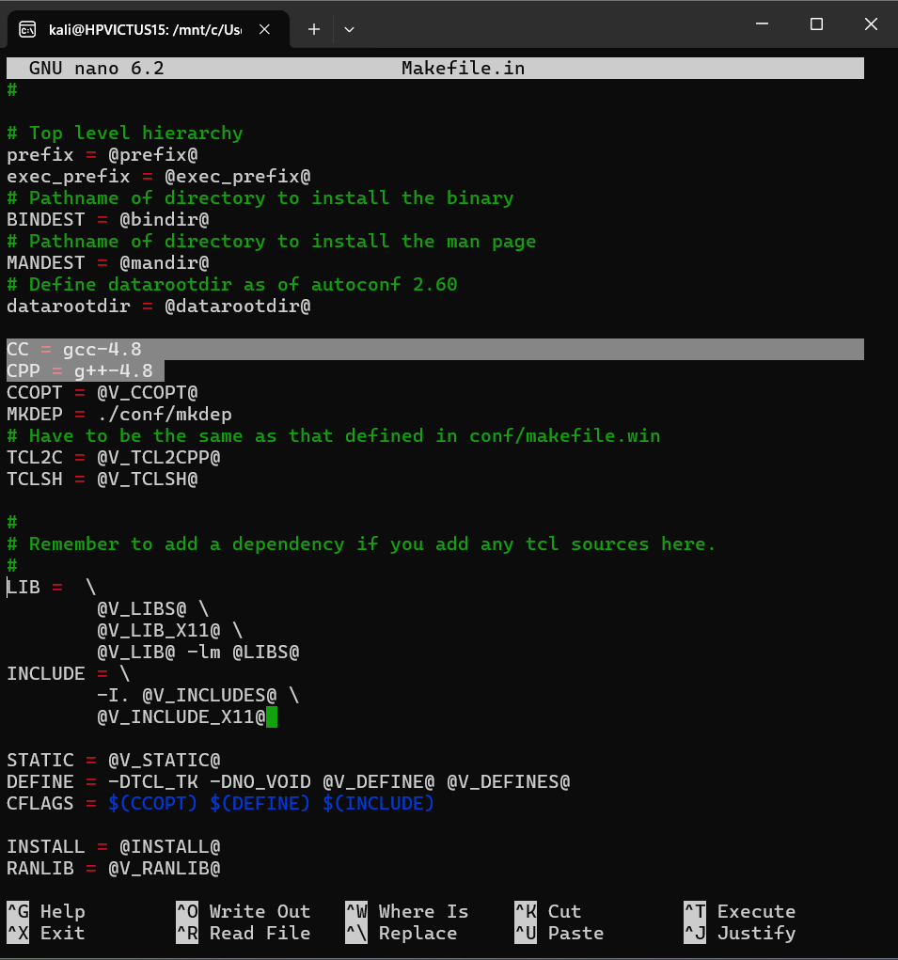

1. **cd xgraph-12.2/**
2. **nano Makefile.in**

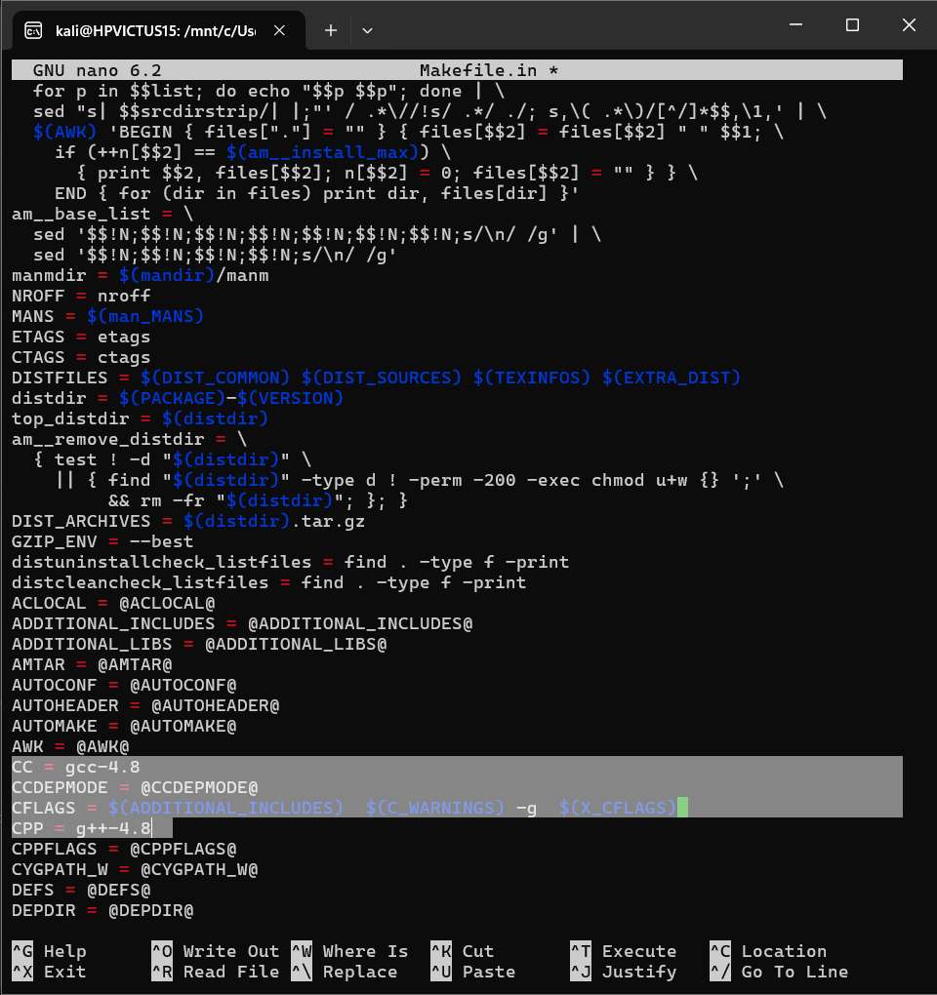

1. **nano ns-2.35/linkstate/ls.h :**

**add line this->**

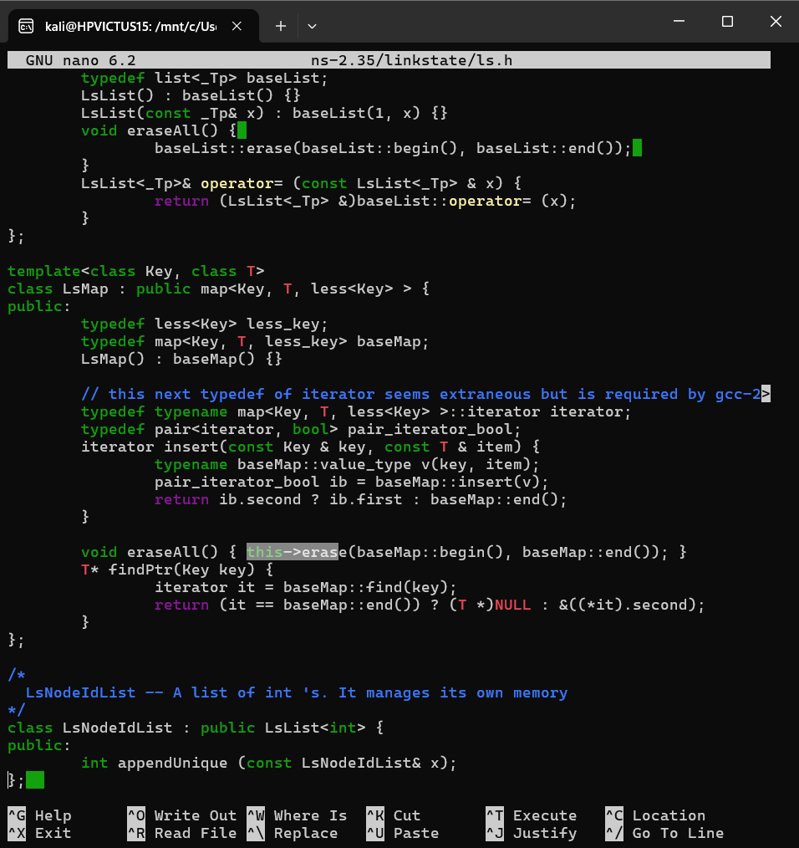

1. **./install :**

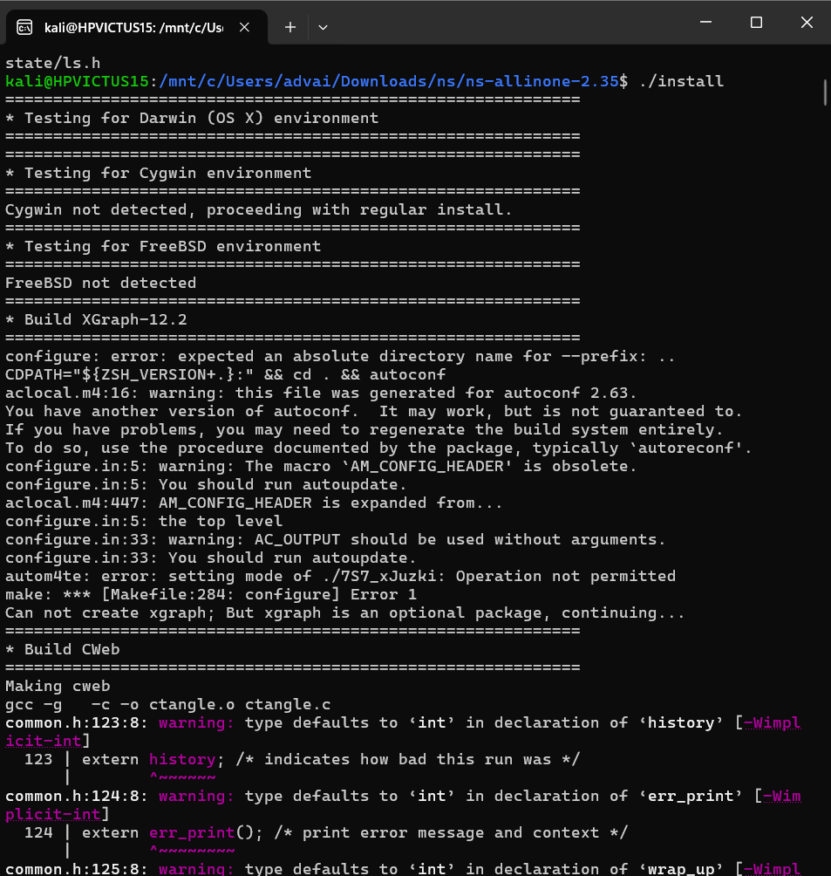

1. **Nano .bashrc :**

**Add path you will get from after ./install**

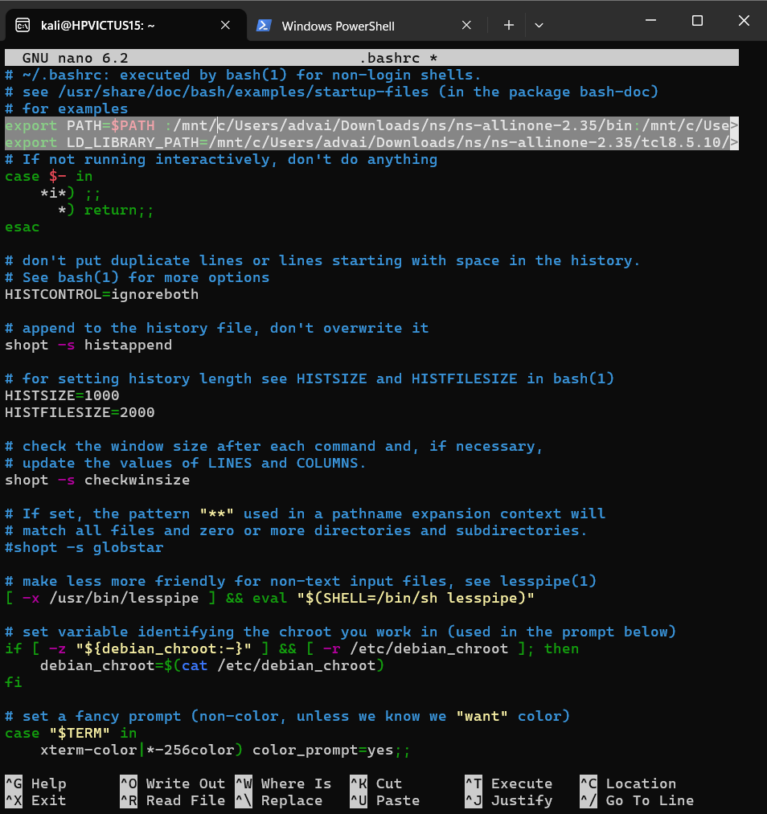

1. **source ~/.bashrc**
2. **ns**
3. **nam**

